# **Pillow Alarm Clock** Systems Manual

Developers: Katarina Galic, Eden Fry, Trang Hoang, Garrett Crayton, Sina Ahmadi

Date: June 2019

## TABLE OF CONTENTS

Contents

**Pillow Alarm Clock** Systems Manual 1

TABLE OF CONTENTS 2

**1. Connector Installation** 3

1.1 Downloading Connector 3

1.2 Installing Necessary Modules 3

**2. Connector Errors** 4

2.1 Server Not Running 4

2.2 Arduino not Connected 4

2.3 Username not Found 4

**3. Website** 5

3.1. Supported Browsers 5

3.2. Running the website locally 5

**4.Website Errors** 5

4.1 User already submitted 5

4.2 Invalid input errors 5

## **1. Connector Installation**

## 1.1 Downloading Connector

Download the connector into the location of your choice. Make sure that it is in a location that you know where it is and can access easily, as you will need to run it in order to start using your connector.

## 1.2 Installing Necessary Modules

There are various different python modules that you will need to install in order to be able to properly run the connector. The necessary modules are as follows:

* datetime
* pySerial
* requests
* regEx

These modules can be installed through the command prompt using “python -m pip install”. Below are examples of how you can install each of the modules.

DateTime:



Serial:



Requests:



RegEx:



## **2. Connector Errors**

## 2.1 Server Not Running

If you have not started running the server, the following message will show up. In order to resolve this problem, make sure that your pillow alarm clock server is running.

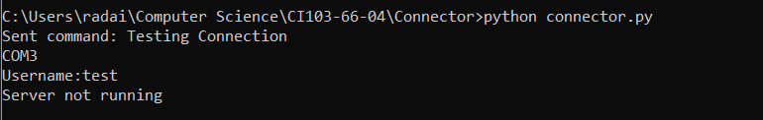

## 2.2 Arduino not Connected

If the Arduino is not plugged in or it can not be found, the following error messages will be shown. If this error message shows up, make sure that your Arduino is plugged in properly.



## 2.3 Username not Found

If the connector can’t find the username that you put in, the following message will show up. Make sure that you spelled your username correctly and that you have put in your username and alarm time on the webpage.



## **3. Website**

## 3.1. Supported Browsers

Our website is compatible with all browsers that we have tested it on, including: Google Chrome, Mozilla Firefox, Microsoft Edge and Microsoft Explorer

## 3.2. Running the website locally

In the case of running the website locally, the users will need to install several libraries. The users need to run the following commands through the command prompt (assuming that they have python installed):

* pip install django
* pip install matplotlib
* pip install Pillow

## **4.Website Errors**

## 4.1 User already submitted

In the event of submitting multiple user IDs with the same name, a message alerting the user that the name has already been submitted shows up, and the user can input again.

## 4.2 Invalid input errors

In the event of submitting a wrong value for time, the user will be redirected to a blank HTML page stating the error:

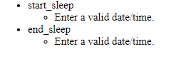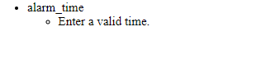

Navigate back to the previous page by clicking back on your browser.

For all other issues, contact the developers through Drexel College of Computing and Informatics, or through the following emails: [kg896@drexel.edu](mailto:kg896@drexel.edu), [emf86@drexel.edu](mailto:emf86@drexel.edu), [tmh327@drexel.edu](mailto:tmh327@drexel.edu), [aa4279@drexel.edu](mailto:aa4279@drexel.edu), [gkc37@drexel.edu](mailto:gkc37@drexel.edu)